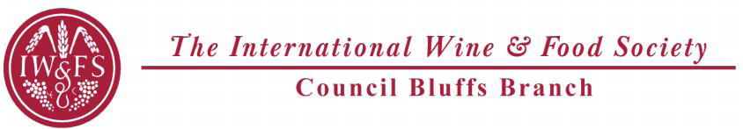

**Oregon Wine Country Dinner**

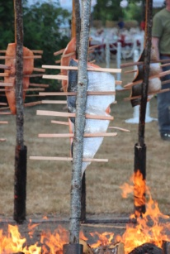

Sunday 11-8-2015 Spezia

Quaffing: 5:00 pm 3125 S. 72nd St

Dinner: 5:30 pm Omaha, NE Dress: Women Dressy Casual Men: Slacks, Sports shirt

Chef: Brian Reilly President Bob Kossow

**Appetizers and Quaffing**

Margherita Flatbread and Sausage & Pepper Flatbread, Smoked Salmon Canapés

2011Argyle Brut, 2013 King Estate Pinot Gris, 2012 Elk Cove Pinot Noir, 2012 Westrey Willamette Valley Pinot Noir 90ST; 2012 Willakenzie Gisèle Vineyard Pinot Noir 90ST;

**First Course**

Honeycrisp Apple Salad with Dried Cranberry and Goat Cheese with Raspberry Vinaigrette

2013 Eyrie Vineyards Dundee Hills Pinot Gris 92 WE, RP 91

2014 Ponzi Willamette Valley Rosé of Pinot Noir 90WE

**Second Course**

Wood Grilled British Columbia Salmon with Herb Risotto and Roasted Tomato

2012 Adelsheim Willamette Valley Pinot Noir 92 WS, 92 WE, 90ST

2012 Ponzi Willamette Valley Pinot Noir 92 WS, 91WE, 90ST

**Intermezzo**

Blood Orange Sorbet

**Third Course**

Wood Grilled Beef Tenderloin with Red Wine Demi Glace and Potato Hash with Caramelized Brussels Sprouts & Fennel

2012 Cristom "Louise Vineyard" Eola-Amity Hills Pinot Noir WA94, 93WS, 92W&S

2012 Roco "Clawson Creek Vineyard" Yamhill-Carlton Pinot Noir 92WS, 91WE, 90ST

**Fourth Course**

Peach Upside-down cake

2013 Andrew Rich Gewurztraminer Ice Wine Celilo Vineyard, Columbia Gorge 95 IWFS CB Board

Event Chairs: Tom and Mary Murnan

$130.00 per Member or Guest. RSVP due by 11-1-2015.

Make checks payable to IWFS CB and mail to Tom Murnan

2507 S 48 St., Omaha, NE 68106