Council Bluffs Branch of International Wine and Food Society
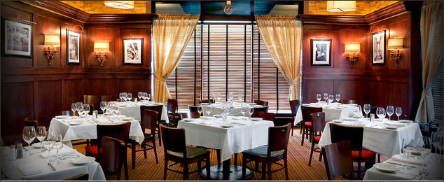

Saturday January 23, 2016 Quaffing 6:30 PM Dinner 7:00 PM

1st Course New England clam chowder
Beringer Private Reserve Chardonnay RP93
(This is wine #2 from movie Somm at 47 minute mark through 54 minute mark available on Neflix online)

2nd Course Roasted beet salad: Goat cheese/baby greens/ orange – thyme vinaigrette
Twomey Merlot WE 91

3rd Course (please choose one)
All entrees are served with seasonal vegetables w hollandaise sauce and kumquat risotto

6 oz. Beef tenderloin filet w seared sea scallop and sauce au poivre
Waterstone Blend JS 93

14 oz Prime NY strip steak w black truffle butter
Hall Cabernet Sauvignon RP 95

7 oz Scottish salmon filet w lemon – thyme cream
Duckhorn Sauvignon Blanc WW 91

Seared sea scallops w lemon – thyme cream
Hendry Unoaked Chardonnay

Desert Course Chocolate Chile crème brule
Zinfandel Port Terra d’Oro WE 93

$130.00 per person Guests Welcome seating for 36
Ladies Dressy Casual Men: Jacket, Tie Optional, Medallion
Hosts: Hasan and Michelle Hyder; David and Debbie Tritsch

Please mail your reservation (check payable to the CB IWFS) by January 16
Hasan Hyder, 704 N 159th St, Omaha, NE 68154

